December 13, 2023 Holden Evening Prayer 6:30 PM
ADVENT 2023
KOUNTZE MEMORIAL LUTHERAN CHURCH
A CITY-WIDE CHURCH WITH A WORLD-WIDE MINISTRY
Lucy Wynard, Senior Pastor 2650 Farnam Street
Shari Duminy, Transitional Associate Pastor Omaha, NE 68131-3616
H. Ashley Hall, Associate Pastor 402-341-7761
www.kmlchurch.org

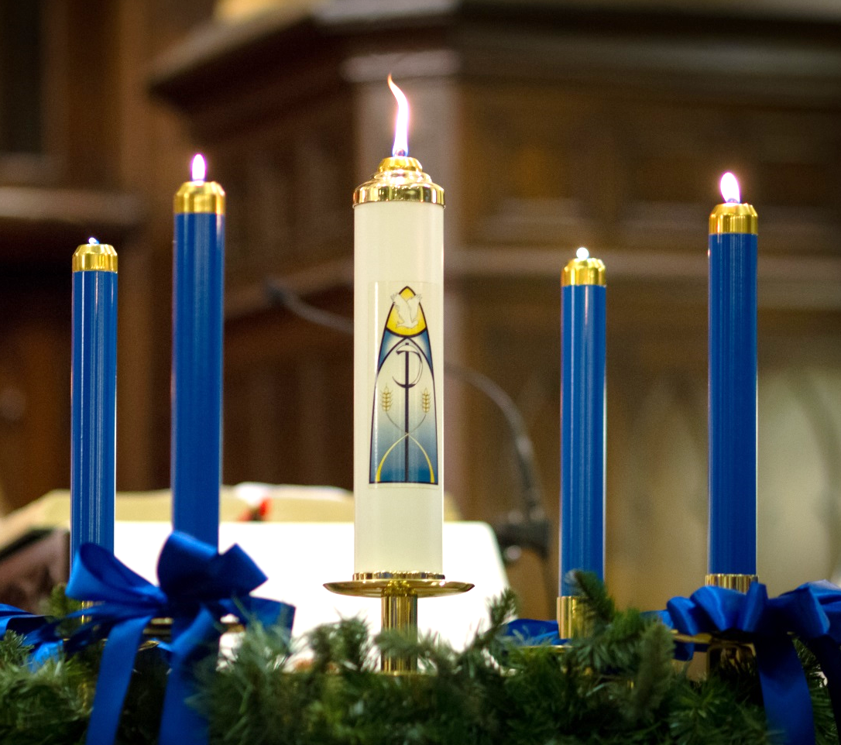

GATHERING

We gather in silent meditation and prayer.
Rise and face the entrance as the service begins when the Sanctus bells ring.

Mark Jones, Organist

SERVICE OF LIGHT

PROCESSION

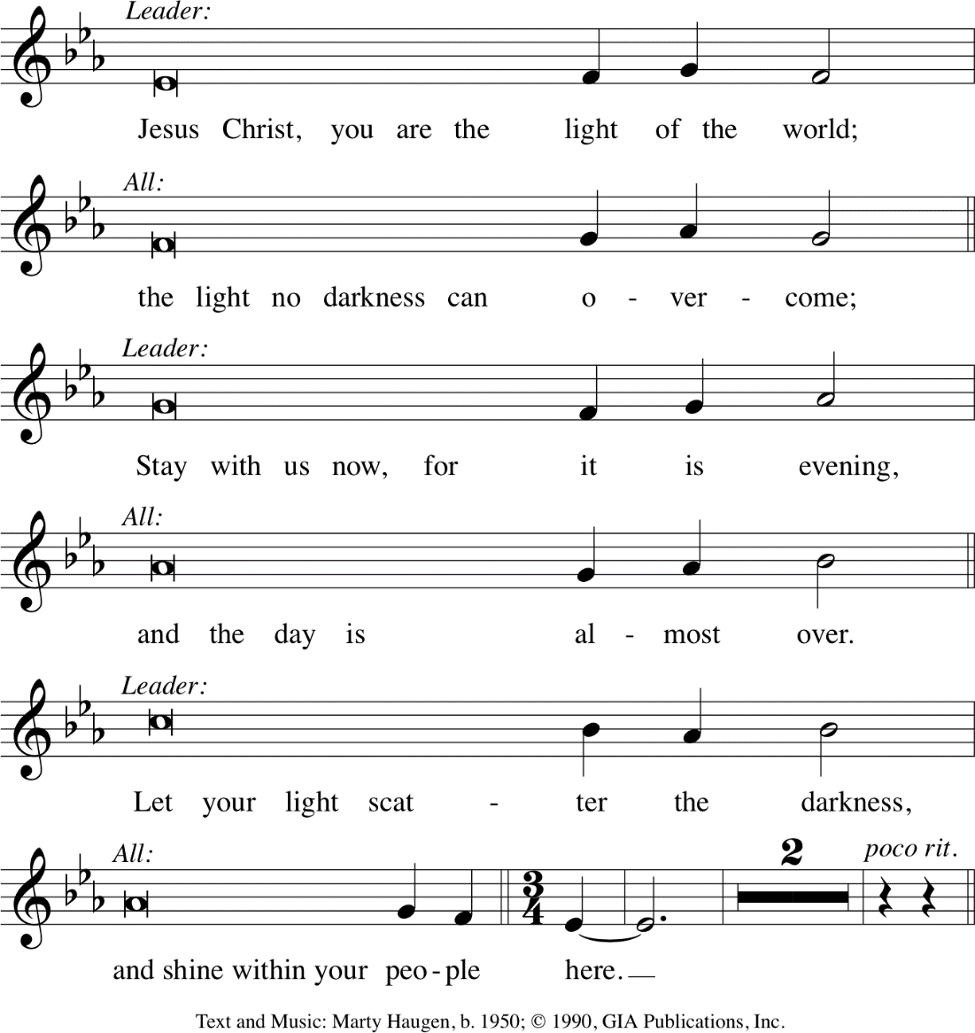

Turn as the service continues with the Evening Hymn.
EVENING HYMN Joyous Light Marty Haugen

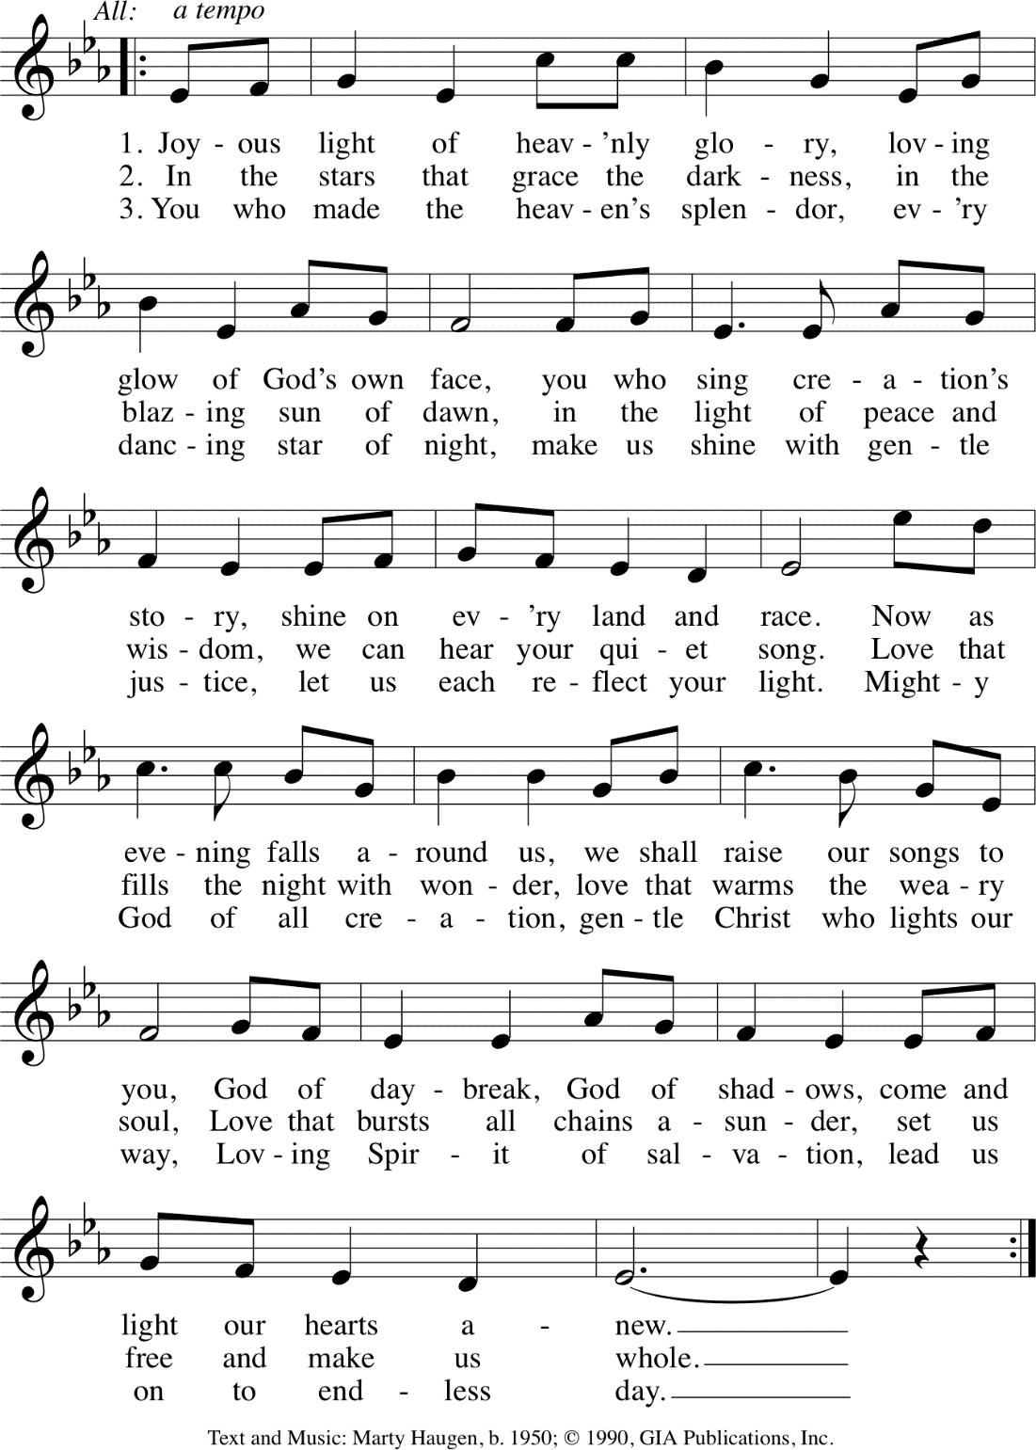

(sit)
LIGHTING OF THE ADVENT WREATH AND PRAYER
P By the light of this second candle we receive your comfort now. By your Spirit, may all of the pain and sorrow that we carry be shouldered by this beloved community. We are not alone, for you are with us and we are with one another. Through the power of mutual aid, we have everything that we need. Our peace comes through our willingness to share the abundance that you have given to us. In Christ Jesus, we pray.
C Amen.

(light two candles)

EVENING THANKSGIVING

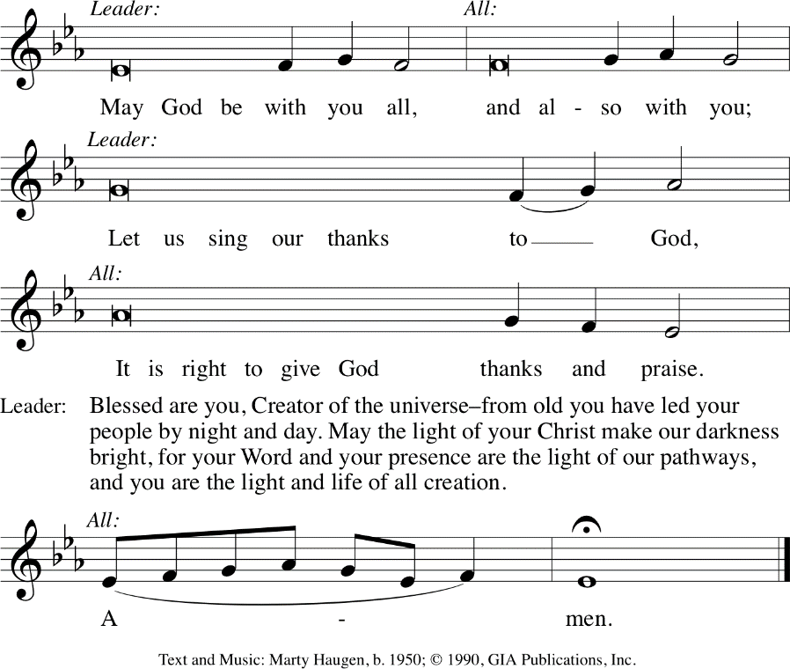

Group One: Low Voices
Group Two: High Voices

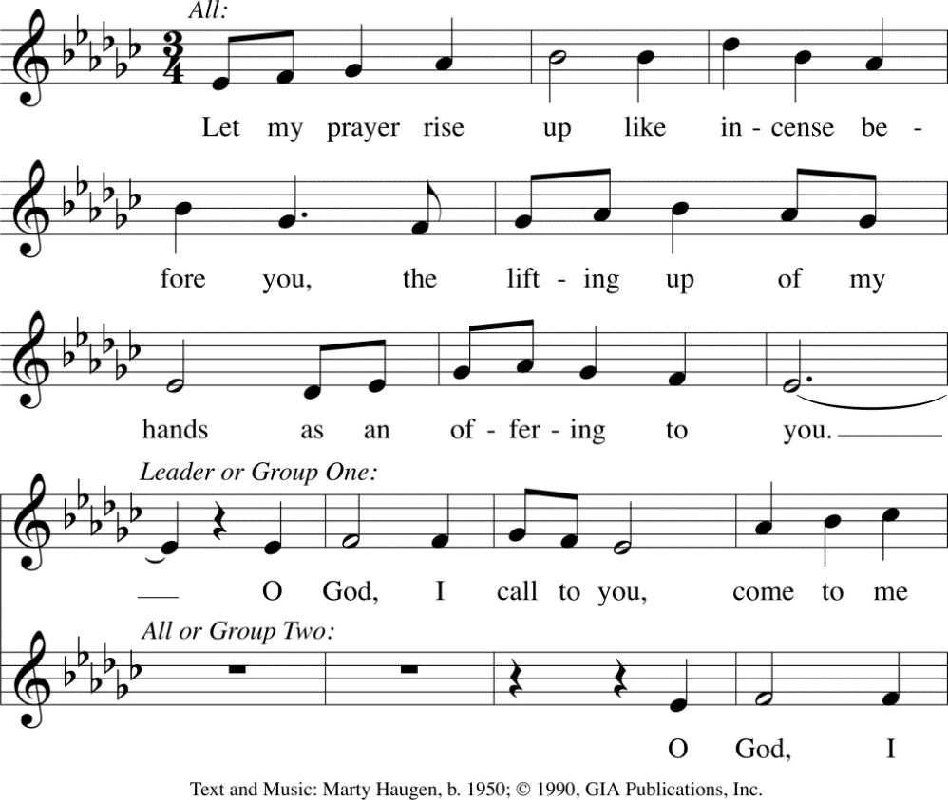
PSALM 141

Silence for Meditation

P May our prayers come before you, O God, as incense, and may your presence surround and fill us, so that in union with all creation, we might sing your praise and your love in our lives.
C Amen.

SILENCE

SCRIPTURE AND REFLECTION Isaiah 40:1-11

C
omfort, O comfort my people, says your God. ²Speak tenderly to Jerusalem, and cry to her that she has served her term, that her penalty is paid, that she has received from the LORD's hand double for all her sins. ³A voice cries out: "In the wilderness prepare the way of the LORD, make straight in the desert a highway for our God. ⁴Every valley shall be lifted up, and every mountain and hill be made low; the uneven ground shall become level, and the rough places a plain. ⁵Then the glory of the LORD shall be revealed, and all people shall see it together, for the mouth of the LORD has spoken." ⁶A voice says, "Cry out!" And I said, "What shall I cry?" All people are grass, their constancy is like the flower of the field. ⁷The grass withers, the flower fades, when the breath of the LORD blows upon it; surely the people are grass. ⁸The grass withers, the flower fades; but the word of our God will stand forever. ⁹Get you up to a high mountain, O Zion, herald of good tidings; lift up your voice with strength, O Jerusalem, herald of good tidings, lift it up, do not fear; say to the cities of Judah, "Here is your God!" ¹⁰See, the Lord GOD comes with might, and his arm rules for him; his reward is with him, and his recompense before him. ¹¹He will feed his flock like a shepherd; he will gather the lambs in his arms, and carry them in his bosom, and gently lead the mother sheep.

INDIVIDUAL PRAYERS AT THE ALTAR
You are invited at this time to come forward, light a candle and offer your prayers to God. Know that God hears you and listens to your requests, questions, thanks, joys and sorrows.

The service continues with the following responses which introduce the Annunciation:

P The Light shines in the darkness C and the darkness has not overcome it.

(stand)
THE ANNUNCIATION Luke 1:26-28, 30-32, 38
P An angel went from God to a town called Nazareth to a woman whose name was Mary. The angel said to her, “Rejoice, O highly favored, for God is with you. You shall bear a child, and his name shall be Jesus, the Chosen One of God Most High.” And Mary said, “I am the servant of my God, I live to do your will.”
(immediately to “The Magnificat”)

THE MAGNIFICAT Luke 1:46-55
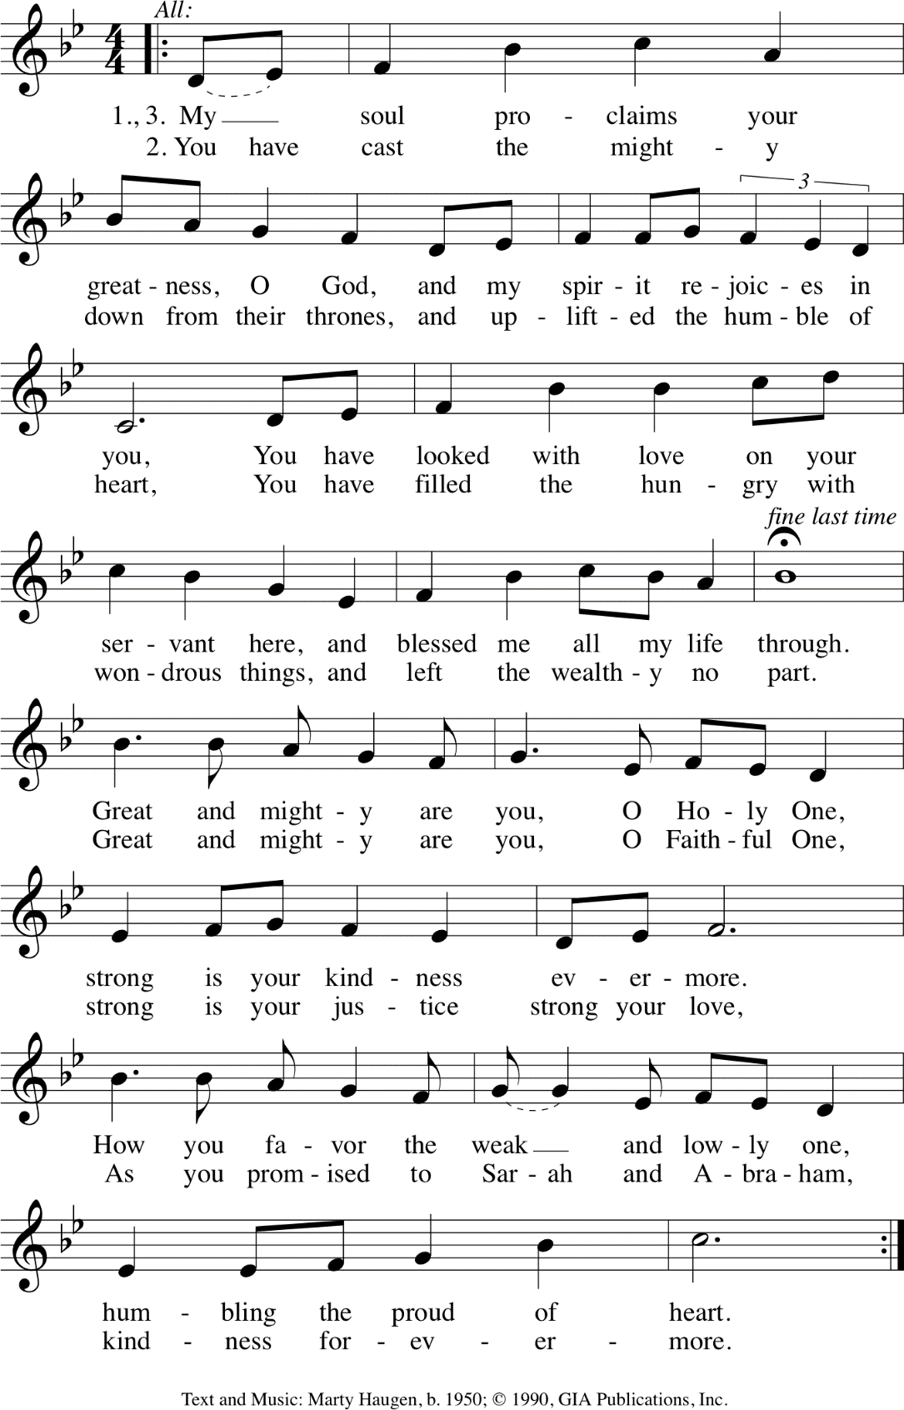

PRAYERS

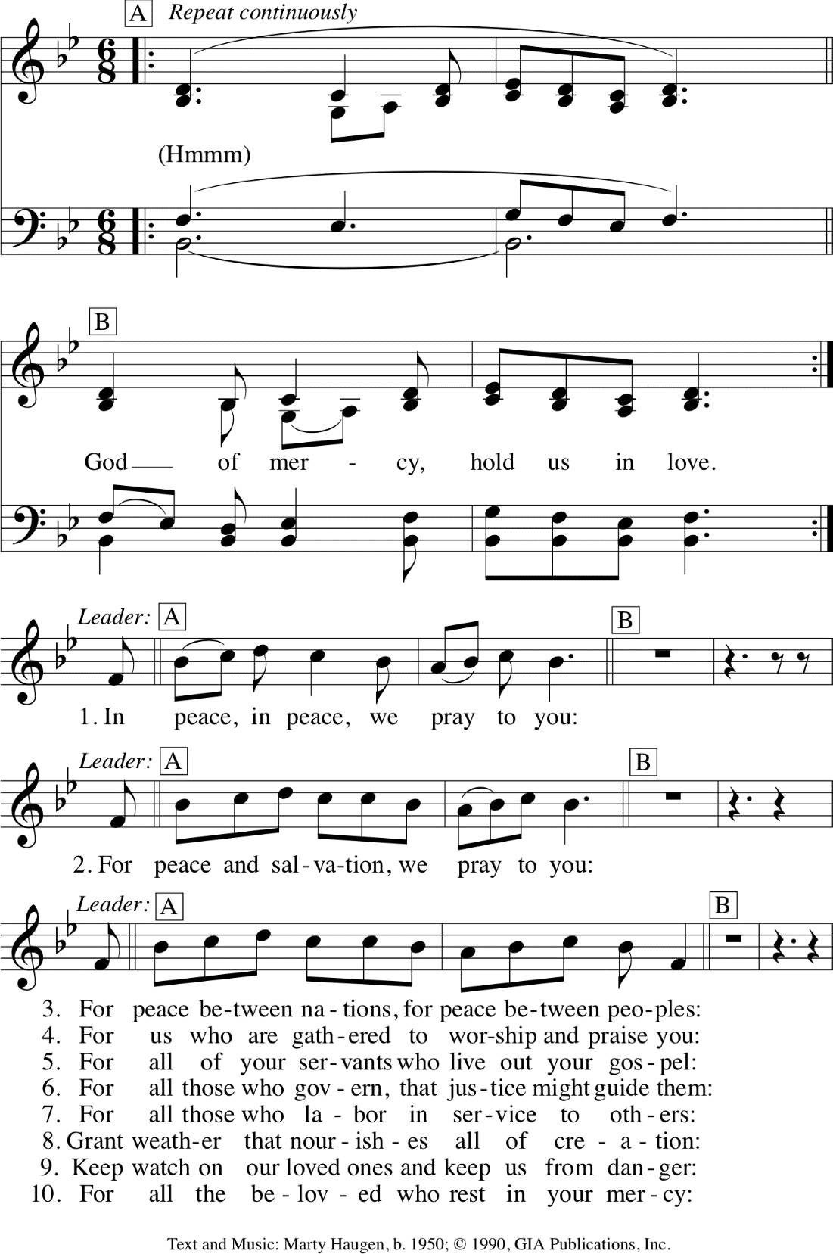

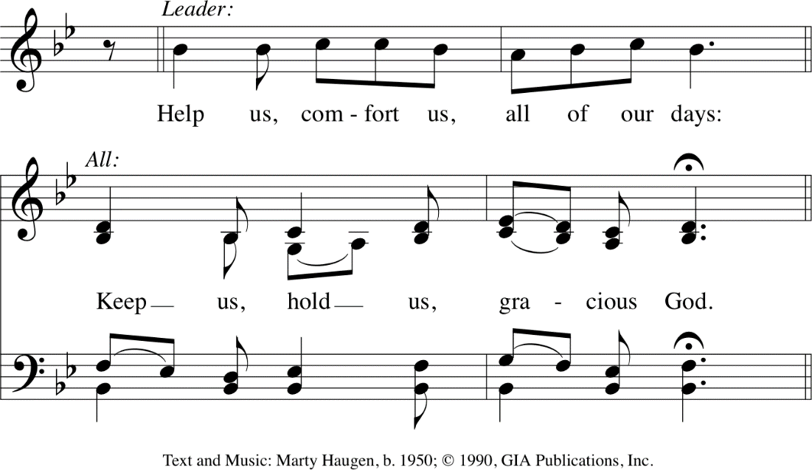

P Great and merciful God, Source and Ground of all goodness and life, give to your people the peace that passes all understanding and the will to live your Gospel of mercy and justice, through Jesus Christ our Lord.
C Amen.
P God, remember us in your love, and teach us to pray:
C Our Father, who art in heaven,
hallowed be thy name, thy kingdom come,
thy will be done, on earth as it is in heaven.
Give us this day our daily bread;
and forgive us our trespasses,
as we forgive those who trespass against us;
and lead us not into temptation, but deliver us from evil.
For thine is the kingdom, and the power, and the glory,
forever and ever. Amen.

(sit)
FINAL BLESSING

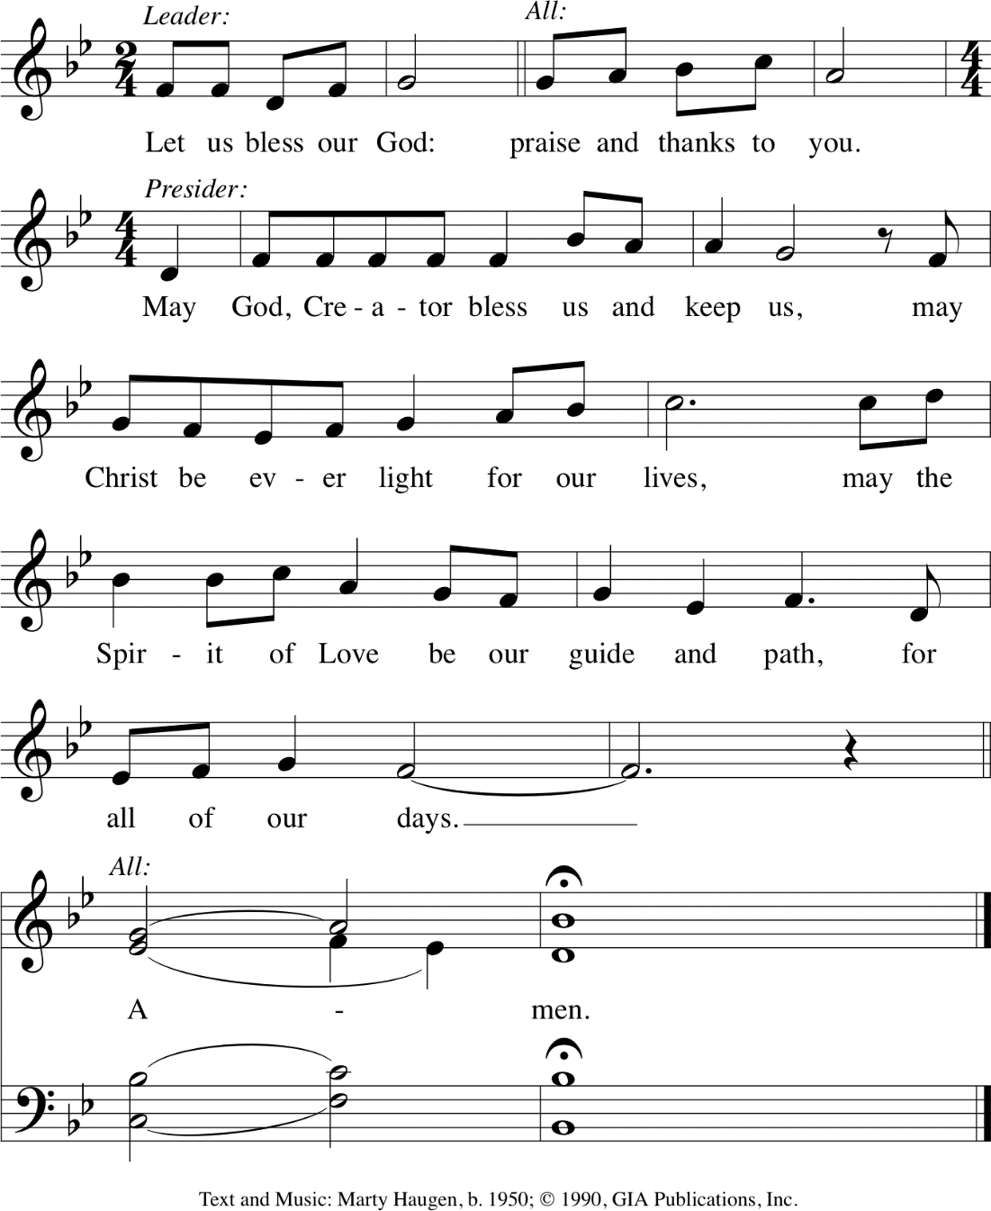

depart in silence

© Church Anew; Confession, Prayer of the Day, Advent Wreath Litany
From Sundays and Seasons.com. ©2022 Augsburg Fortress. All rights reserved. Reprinted by permission under Augsburg Fortress Liturgies Annual License #SAS006828. Reprinted under OneLicense.net #A-705181. New Revised Standard Version Bible, ©1989, Division of Christian Education of the National Council of the Churches of Christ in the United States of America. Used by permission. All rights reserved. Evangelical Lutheran Worship ©2006 Augsburg Fortress. All Creations Sings ©2020 Augsburg Fortress, an imprint of 1517 Media. Reprinted by permission under Augsburg Fortress Liturgies Annual License #26828. CCLI License #1511530.

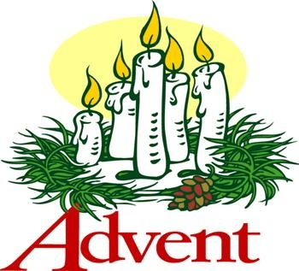
Wednesdays, December 20
Lunch: 11:00 AM – Noon
Supper: 5:00 – 6:30 PM
Worship: 6:30 PM

Weekend Worship Times
Saturdays: 5:00 PM
Sundays: 9:00 & 11:00 AM
Please Note: Sunday, December 24, no 11:00 AM worship service

Candlelight Carol Service
Saturday, December 16, 5:00 PM

Children’s Christmas Program
Sunday, December 17, 9:00 AM

December 24
Advent 4: 9:00 (no 11:00 AM)
Christmas Eve: 4:00, 7:00, 11:00 PM

December 25
Christmas Day: 10:00 AM

